Software Engineering
Software Requirements Specification (SRS)
Project: Change Management Software
Version: 1.0
Authors: team 16- Nidhi S, Uthkarsha, Harshith k k
Date: 13-09-2026
Status: Draft

Revision History
Version | Date | Authors | Change Summary
1.0 | 13-09-2026 | Team 16 | Initial draft

Approvals
Role | Name | Signature / Date
Course Coordinator | Arpitha.K, Assistant Professor
Project Guide | Arpitha.K, Assistant Professor

Table of Contents
- 1. Introduction
- 2. Overall Description
- 3. External Interface Requirements
- 4. System Features — Functional Requirements
- 5. Non-Functional Requirements
- 6. Security Objectives & Requirements
- 7. Quality Attributes & Acceptance Tests
- 8. UML Diagrams
- 9. Requirements Traceability Matrix (RTM)

1. Introduction

1.1 Purpose
This document is a Software Requirements Specification (SRS) for the Change Management Software (CMS). It defines the functional and non-functional requirements, interfaces, and verification criteria for the project team, project guide, and evaluators.

1.2 Scope
Covers submission, review, and approval of change requests (CRs) through a Change Advisory Board (CAB) workflow, scheduling of approved changes, implementation tracking, and audit reporting. Excludes underlying IT infrastructure provisioning and the internal workings of any third-party ITSM tools beyond their integration APIs.

1.3 Audience
Developers, QA engineers, the project guide/evaluators, and end users (Requesters, CAB Members/Approvers, Implementers, Administrators).

1.4 Definitions
CMS (Change Management Software), CR (Change Request), CAB (Change Advisory Board), RFC (Request for Change), RBAC (Role-Based Access Control), SLA (Service Level Agreement), ITIL (Information Technology Infrastructure Library), API (Application Programming Interface), UI (User Interface).

2. Overall Description

2.1 Product Perspective
The CMS is a web-based application that manages the lifecycle of a change request from submission through CAB review, approval, scheduling, implementation, and closure, integrating with a notification service and a reporting module.

2.2 Major Product Functions
- User registration and role-based authentication
- Submit and track change requests (CRs)
- Risk and impact assessment
- CAB review and approval / rejection workflow
- Change scheduling and calendar management
- Implementation tracking and rollback planning
- Notifications and alerts
- Audit trail and reporting
- Administration and workflow configuration

2.3 User Roles and Characteristics
- Requester: submits change requests and tracks their status.
- CAB Member / Approver: reviews risk, discusses, and approves or rejects change requests.
- Implementer: executes approved changes and updates implementation status.
- Administrator: manages users, roles, and workflow configuration.

2.4 Operating Environment
Web application hosted on a college lab server or a free-tier cloud host, accessible via modern browsers, with a relational database backend.

2.5 Constraints
Must support role-based access control, tamper-evident audit logging, integration with an email/notification service, and general alignment with ITIL change-management practice. Development is scoped to a three-member student team within an academic timeline.

3. External Interface Requirements

3.1 User Interfaces
A web-based dashboard with forms for CR submission, approval queues, and a change calendar view. Interfaces use readable fonts, clear labelling, and keyboard-navigable forms.

3.2 Hardware Interfaces
Standard client devices (desktop, laptop, or tablet) with a modern web browser. No specialised hardware is required.

3.3 Software Interfaces
- Email / Notification API (SMTP or a third-party service) for status alerts.
- Optional integration API with an external ITSM tool (e.g., Jira) for CR import / export.
- Relational database for persistence of users, CRs, approvals, and audit logs.

3.4 Communications
HTTPS/TLS 1.2+ is enforced for all client-server communication; REST APIs are used for all integrations.

4. System Features (Detailed)-Functional requirements
Each requirement below includes acceptance criteria and a reference test case. IDs follow CM-F-###.

4.1 Authentication & Access Control
Description: Authenticate users and enforce role-based access for Requesters, CAB Members, Implementers, and Administrators.
Req ID | Requirement | Type | Priority | Source | Acceptance Criteria / Test Ref | Comments
CM-F-001 | The system shall authenticate users via username and password and enforce a session timeout after inactivity. | Functional | High | Security | AC-CM-F-001: Valid credentials grant access; expired session forces re-login. Test: TC-Auth-01 | Depends on Auth Service
CM-F-002 | The system shall enforce role-based access control (RBAC), restricting menus and actions by role. | Functional | High | Security / Business | AC-CM-F-002: Users see only actions permitted for their role. Test: TC-Auth-02 | Roles: Requester, CAB, Implementer, Admin
CM-F-003 | The system shall lock a user account after 5 consecutive failed login attempts and notify the administrator. | Functional | Medium | Security | AC-CM-F-003: Account locked after 5 failures; admin notified. Test: TC-Auth-03 | Manual unlock by Admin

4.2 Change Request Submission
Description: Allow a requester to create and submit a change request with supporting details.
Req ID | Requirement | Type | Priority | Source | Acceptance Criteria / Test Ref | Comments
CM-F-010 | The system shall allow a requester to create a CR specifying title, description, category, priority, and affected systems. | Functional | High | Business | AC-CM-F-010: CR saved with a unique ID and status "Submitted". Test: TC-CR-01 | -
CM-F-011 | The system shall allow attachment of supporting documents to a CR, validating file size and type. | Functional | Medium | Business | AC-CM-F-011: Valid files attach; oversized or invalid types are rejected. Test: TC-CR-02 | Max size configurable
CM-F-012 | The system shall allow a requester to view the status and history of their own change requests. | Functional | High | Business | AC-CM-F-012: Status timeline reflects every state change. Test: TC-CR-03 | -
CM-F-020 | The system shall allow a CAB member to record a risk level (Low/Medium/High) for a change request. | Functional | High | Business | AC-CM-F-020: Risk level saved and visible on the CR. Test: TC-Risk-01 | -
CM-F-021 | The system shall block submission of a High-risk change request unless a rollback plan is attached. | Functional | High | Business | AC-CM-F-021: Submission rejected without rollback plan for High risk. Test: TC-Risk-02 | -
CM-F-030 | The system shall allow a CAB member to approve or reject a change request with mandatory comments. | Functional | High | Business | AC-CM-F-030: Decision + comments saved against the CR. Test: TC-Appr-01 | -
CM-F-040 | The system shall display a change calendar and flag scheduling conflicts with configured blackout periods. | Functional | High | Business | AC-CM-F-040: Conflicting schedule attempts are blocked/warned. Test: TC-Sched-01 | -
CM-F-050 | The system shall email the requester automatically whenever their change request's status changes. | Functional | Medium | Business | AC-CM-F-050: Email sent on every status transition. Test: TC-Notif-01 | -

4.3 Risk & Impact Assessment
Requirements: The system shall allow a CAB member to record a risk level (Low / Medium / High), an impact assessment, and confirm whether a rollback plan is attached. Submission shall be rejected for High-risk changes without a rollback plan. IDs: CM-F-020 .. CM-F-023.

4.4 Approval Workflow (CAB)
Requirements: Route CRs to designated CAB members, capture approve / reject / request-more-information decisions with comments, and support multi-level approval and delegation for High-risk changes. IDs: CM-F-030 .. CM-F-034.

4.5 Scheduling & Implementation Tracking
Requirements: Provide a change calendar to schedule approved changes while flagging conflicts with configured blackout periods; track implementation status (Scheduled / In Progress / Completed / Failed / Rolled Back); and capture post-implementation review notes. IDs: CM-F-040 .. CM-F-044.

4.6 Notifications & Reporting
Requirements: Notify requesters and CAB members by email at key status transitions; generate audit and summary reports of CR volume, approval turnaround, and implementation success rate. IDs: CM-F-050 .. CM-F-053.

5. Non-Functional Requirements (Detailed)
NFRs below are measurable and tied to the test plan. IDs follow CM-NF-###.
Req ID | Requirement | Category | Priority | Acceptance Criteria / Measurement
CM-NF-001 | Overall page response time shall be ≤ 3 seconds for 95% of requests under normal load. | Performance | High | 95th percentile ≤ 3s in load test. Test: TC-Perf-01
CM-NF-002 | The system shall provide 99.5% availability monthly, excluding scheduled maintenance windows. | Reliability | High | Uptime reports show ≥ 99.5% per month
CM-NF-003 | All actions on change requests shall be logged with timestamp and user ID, retained for 3 years for audit purposes. | Audit / Compliance | High | Audit log verified complete and immutable. Test: TC-OPS-01
CM-NF-004 | The system shall support at least 50 concurrent users without breaching response-time targets. | Performance / Scalability | Medium | Load test with 50 concurrent users meets targets. Test: TC-Perf-02
CM-NF-005 | The system shall conform to WCAG 2.1 AA accessibility guidelines for key workflows. | Usability / Accessibility | Medium | Accessibility audit pass. Test: TC-UX-01

6. Security Objectives & Requirements

6.1 Security Objectives
- Ensure that only authorised users can create, approve, or implement change requests, preserving the confidentiality and integrity of the approval process.
- Maintain a complete, tamper-evident audit trail of all change-related actions to support accountability and compliance.

6.2 Security Requirements
Req ID | Requirement | Type | Priority | Acceptance Criteria / Test Ref
CM-SR-001 | TLS 1.2+ shall be mandatory for all network connections. | Security | High | AC-CM-SR-001: Connections on TLS < 1.2 are rejected. Test: TC-Sec-01
CM-SR-002 | Passwords shall be stored using a salted cryptographic hash; plaintext passwords shall never be stored or logged. | Security | High | AC-CM-SR-002: DB inspection shows hashed values only. Test: TC-Sec-02
CM-SR-003 | Role-based access control shall be enforced on every API endpoint and UI action, not only in the UI layer. | Security | High | AC-CM-SR-003: Direct API calls by an unauthorised role are rejected (403). Test: TC-Sec-03
CM-SR-004 | The system shall record all authentication attempts, approvals, and rejections in an audit trail that standard users cannot alter or delete. | Security | High | AC-CM-SR-004: Audit records are immutable to non-admin roles. Test: TC-Sec-04
CM-SR-005 | The system shall expire a session after 15 minutes of inactivity and require re-authentication for high-risk actions such as final approval. | Security | Medium | AC-CM-SR-005: Session expires as configured; re-auth prompt shown. Test: TC-Sec-05

7. Quality Attributes & Acceptance Tests
Exit criteria for acceptance: all high-priority functional requirements are implemented and verified, no critical NFR failures remain open, and the RTM shows all planned test cases passed.
Acceptance test suites: Authentication, CR Submission, Risk Assessment, Approval Workflow, Scheduling, Performance, Security, and Accessibility.

8. UML Diagrams
Use-case diagram showing the two primary actors (Requester; CAB Approver / Administrator) and the main use cases of the Change Management Software, including include-relationships between a base use case and the step it always performs.
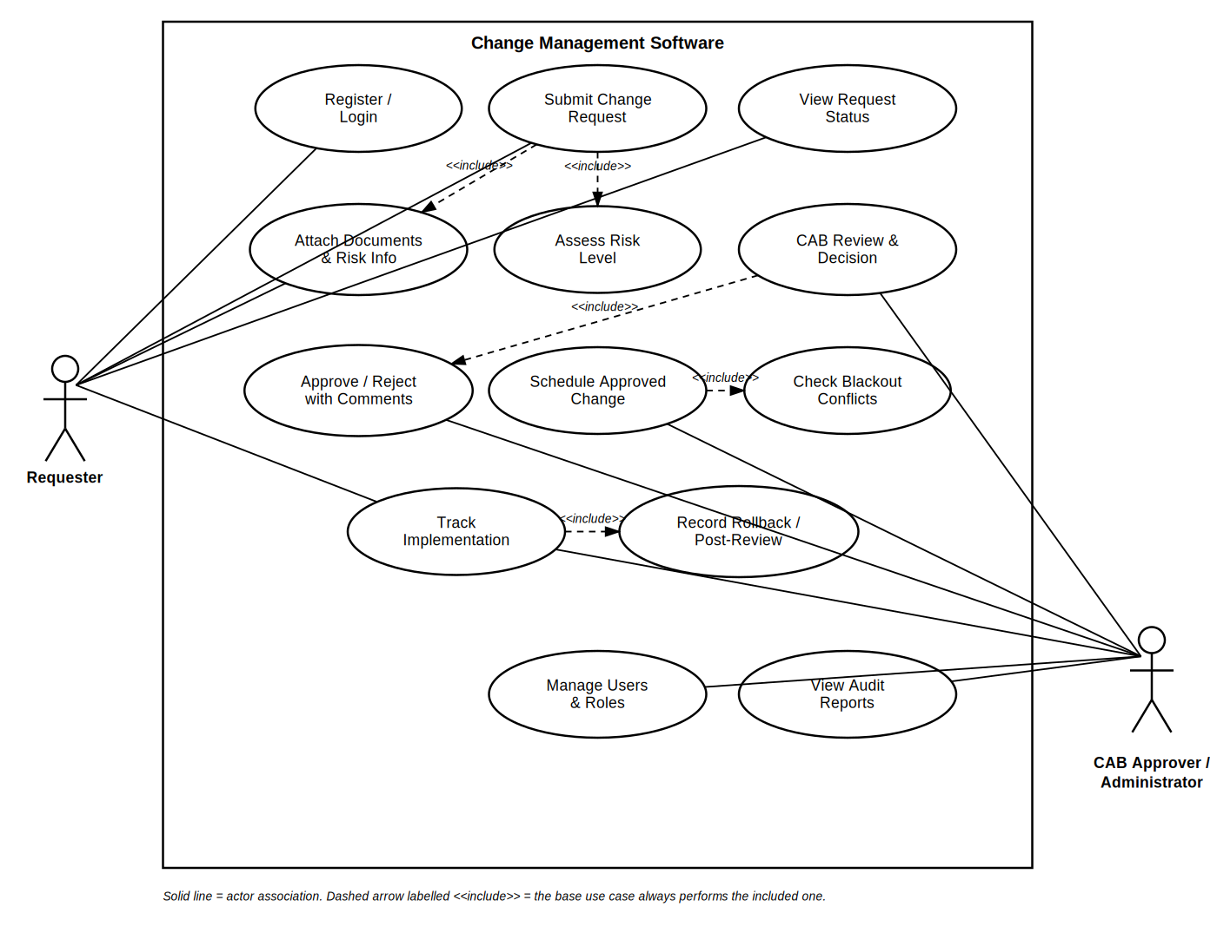
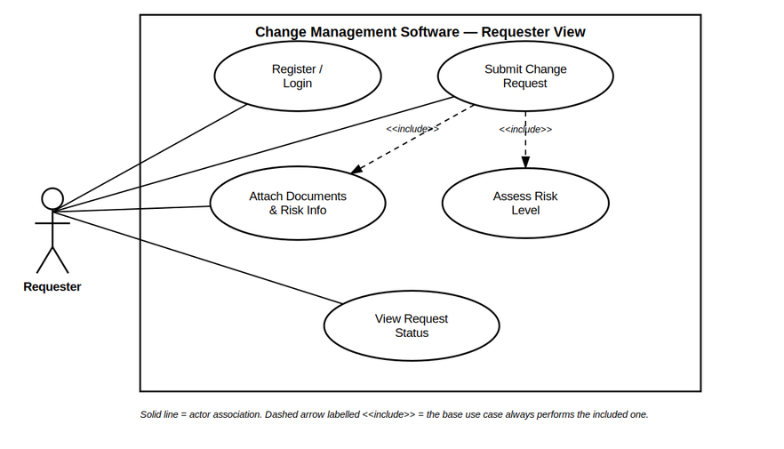
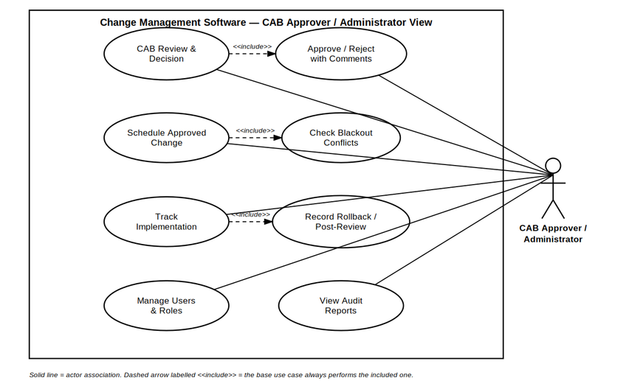
Note: at least one additional UML diagram (e.g., a sequence diagram for the CR-submission-to-approval flow) is recommended and is provided in the Software Architecture and Design Specification.

9. Requirements Traceability Matrix (RTM)
Req ID | Requirement (short) | Section Ref / Design Spec | Module | Test Case(s) | Status | Comments
CM-F-001 | User authentication | 4.1 / DS-Auth-01 | Auth Service | TC-Auth-01 | Not started | -
CM-F-010 | Submit change request | 4.2 / DS-CR-01 | Change Request Service | TC-CR-01, TC-CR-02 | Not started | -
CM-F-020 | Record risk level & rollback plan | 4.3 / DS-Risk-01 | Change Request Service | TC-Risk-01 | Not started | -
CM-F-030 | CAB approval decision | 4.4 / DS-Approval-01 | Approval / Workflow Engine | TC-Appr-01 | Not started | -
CM-F-040 | Schedule approved change | 4.5 / DS-Sched-01 | Scheduler Service | TC-Sched-01 | Not started | -
CM-NF-001 | Response time target | 5 / DS-Perf-01 | Web UI / API | TC-Perf-01 | Not started | -
CM-SR-002 | Password hashing | 6.2 / DS-Auth-02 | Auth Service | TC-Sec-02 | Not started | -

-------------------------------------------------------------------------------------------------------------------------------------

